Name: ID:
Email:
Keystone Algebra 1 Review Module 3 51-75
Multiple Choice
Identify the choice that best completes the statement or answers the question.
 | 1. | What is the multiplicative inverse of ½?  a. -2 c.  b. d. 2
 | 2. | What is the solution for this equation?  a. c.  b. d.
 | 3. | What is the solution set of the inequality?  a. c.  b. d.
 | 4. | Which equation is equivalent to the following equation?  a. c.  b. d.
 | 5. | Which equation is equivalent to the following equation?  a. c.  b. d.
 | 6. | The total cost (c) in dollars of renting a sailboat for n days is given by the equation  If the total cost was $360, for how many days was the sailboat rented?  a. 2 c. 6  b. 4 d. 8
 | 7. | Solve:  Step 1:  Step 2:  Step 3:  Step 4:  Which is the first incorrect step in the solution shown above?  a. Step 1 c. Step 3  b. Step 2 d. Step 4
 | 8. | A 120-foot-long rope is cut into 3 pieces. The first piece of rope is twice as long as the second piece of rope. The third piece of rope is three times as long as the second piece of rope. What is the length of the longest piece of rope?  a. 20 feet c. 60 feet  b. 40 feet d. 80 feet
 | 9. | The cost to rent a construction crane is $750 per day plus $250 per hour for use. What is the maximum number of hours the crane can be used each day if the rental cost is not to exceed $2500 per day?  a. 2.5 c. 7.0  b. 3.7 d. 13.0
 | 10. | 1. What is the solution to the inequality?  a. c.  b. d.
 | 11. | The lengths of the sides of a triangle are y, y + 1, and 7 centimeters. If the perimeter is 56 centimeters, what is the value of y?  a. 24 c. 31  b. 25 d. 25
 | 12. | Which number serves as a counterexample to this statement below?  All positive integers are divisible by 2 or 3.  a. 100 c. 30  b. 57 d. 25
 | 13. | What is the conclusion of the statement in the box below?  If , then .  a. c.  b. d.
 | 14. | Which of the following is a valid conclusion to the statement “If a student is a high school band member, then the student is a good musician”?  a. All good musicians are high school band members. c. All students are good musicians.  b. A student is a high school band member. d. All high school band members are good musicians.
 | 15. | The chart below shows an expression evaluated for hour different values of x.  x  1 7  2 11  6 47  7 61  Josiah concluded that for all positive values of x, produces a prime number. Which value of x serves as a counterexample to prove Josiah’s conclusion false?  a. 5 c. 16  b. 11 d. 21
 | 16. | John’s solution to an equation is shown below.  Given:  Step 1:  Step 2:  Step 3:  Which property of real numbers did John use for Step 2?  a. Multiplication Property of Equality c. Commutative Property of Multiplication  b. Zero Product Property of Multiplication d. Distributive Property of Multiplication over Addition
 | 17. | Stan’s solution to an equation is shown below.  Given:  Step 1:  Step 2:  Step 3:  Step 4:  Step 5:  Step 6:  Which statement about Stan’s solution is true?  a. Stan’s solution is correct. c. Stan made a mistake in Step 3.  b. Stan made a mistake in Step 1. d. Stan made a mistake in Step 5.
 | 18. | When is this statement true?  The opposite of a number is less than the original number.  a. This statement in never true. c. This statement is true for positive numbers.  b. This statement is always true. d. This statement is true for negative numbers.
 | 19. | What is the y-intercept of the graph of  ?  a. – 4 c. 6  b. – 2 d. 12
 | 20. | Which inequality is shown on the graph below?  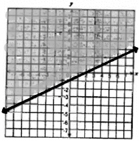  a. c.  b. d.
 | 21. | Which inequality does the shaded region of the graph represent?  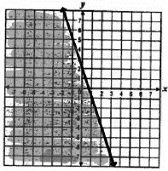  a. c.  b. d.
 | 22. | Which best represents the graph of  ?  a. c.  b. d.
 | 23. | Which equation best represents the graph below?  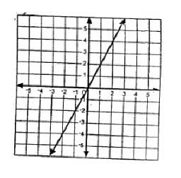  a. c.  b. d.
 | 24. | Which point lies on the line defined by the equation?  a. (0, 2) c.  b. (0, 6) d.
 | 25. | What is the equation of the line that has a slope of 4 and passes through the point (3, -10)?  a. c.  b. d.

